Assignment 8.2

1. Find the number of students who scored less than 5(50%).

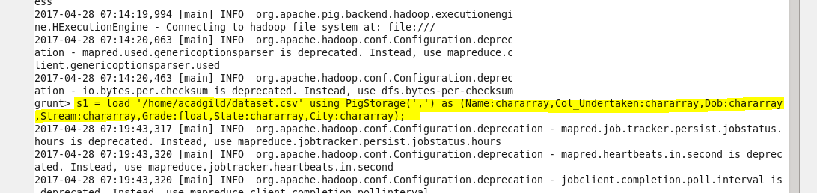



RESULT

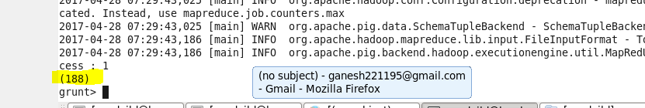

2. List the name of students who are from Alaska.

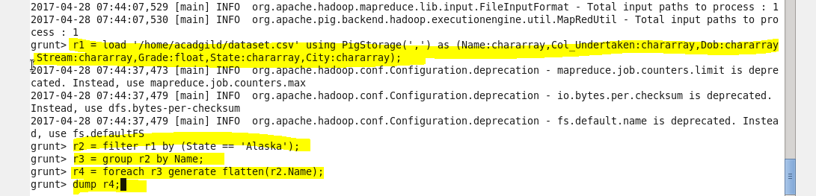

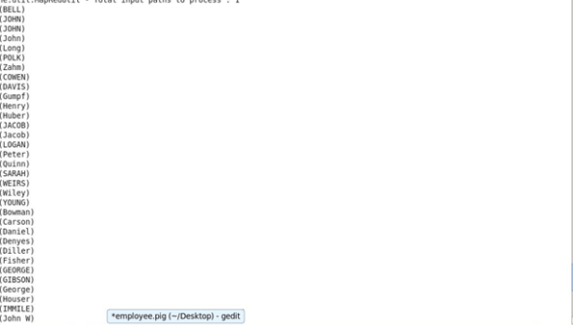



3. How many government colleges are there in Alabama?

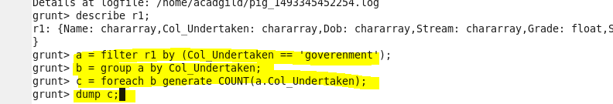

RESULT



4. List the name of students who are from Oregon and pursuing BE.

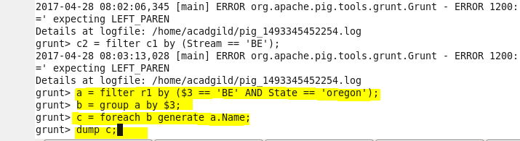

RESULT

